Team Name - CodeOurSouls

Team Members - [Harika Satti](mailto:harika.satti@sjsu.edu), [Ravi Teja Reddy Dodda](mailto:ravitejareddy.dodda@sjsu.edu), [Siddhant Sancheti](mailto:siddhant.sancheti@sjsu.edu), [Naga Bathula](mailto:nagasrinivasarao.bathula@sjsu.edu), [Sanjana Rajesh Kothari](mailto:sanjanarajesh.kothari@sjsu.edu)

Assignment -

1. Download free trial of Tableau Desktop
2. Complete lessons in Companion Workbook and document.

**Installation and accessing companion workbook**

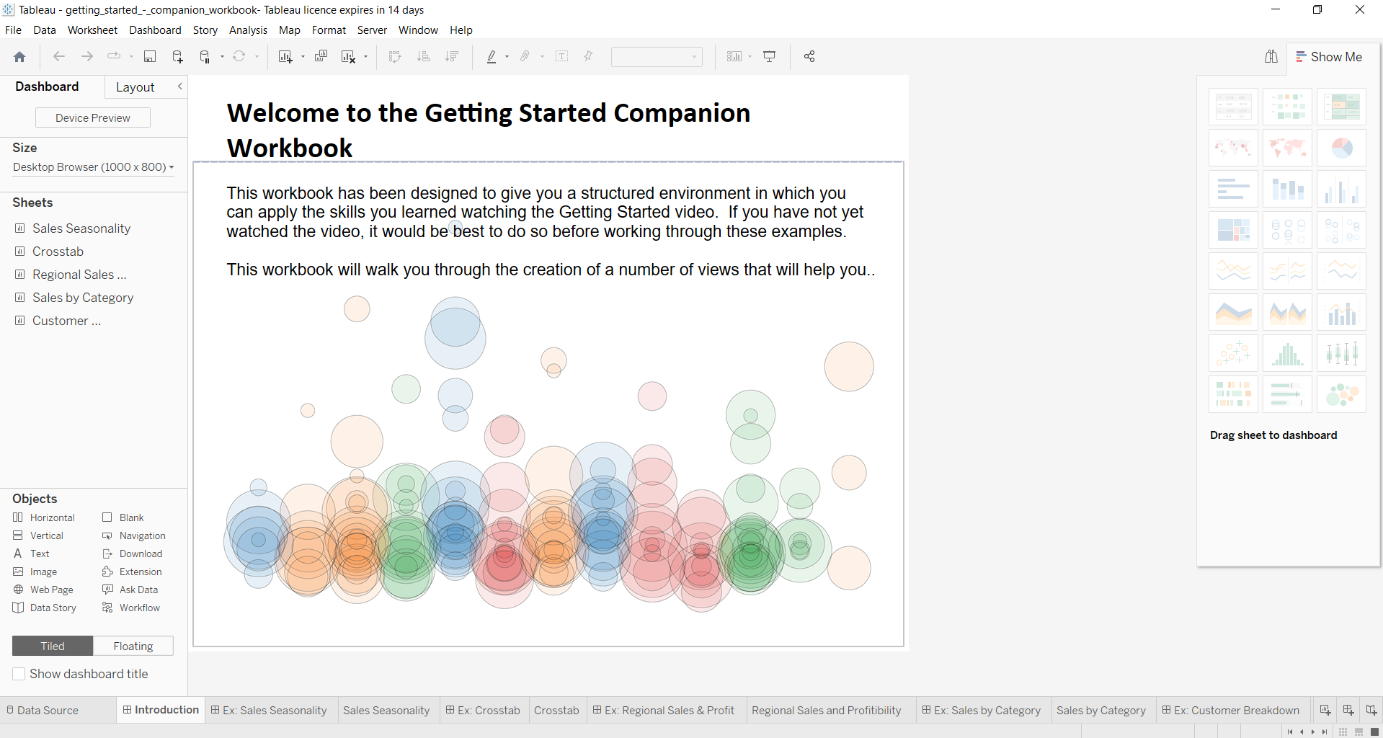

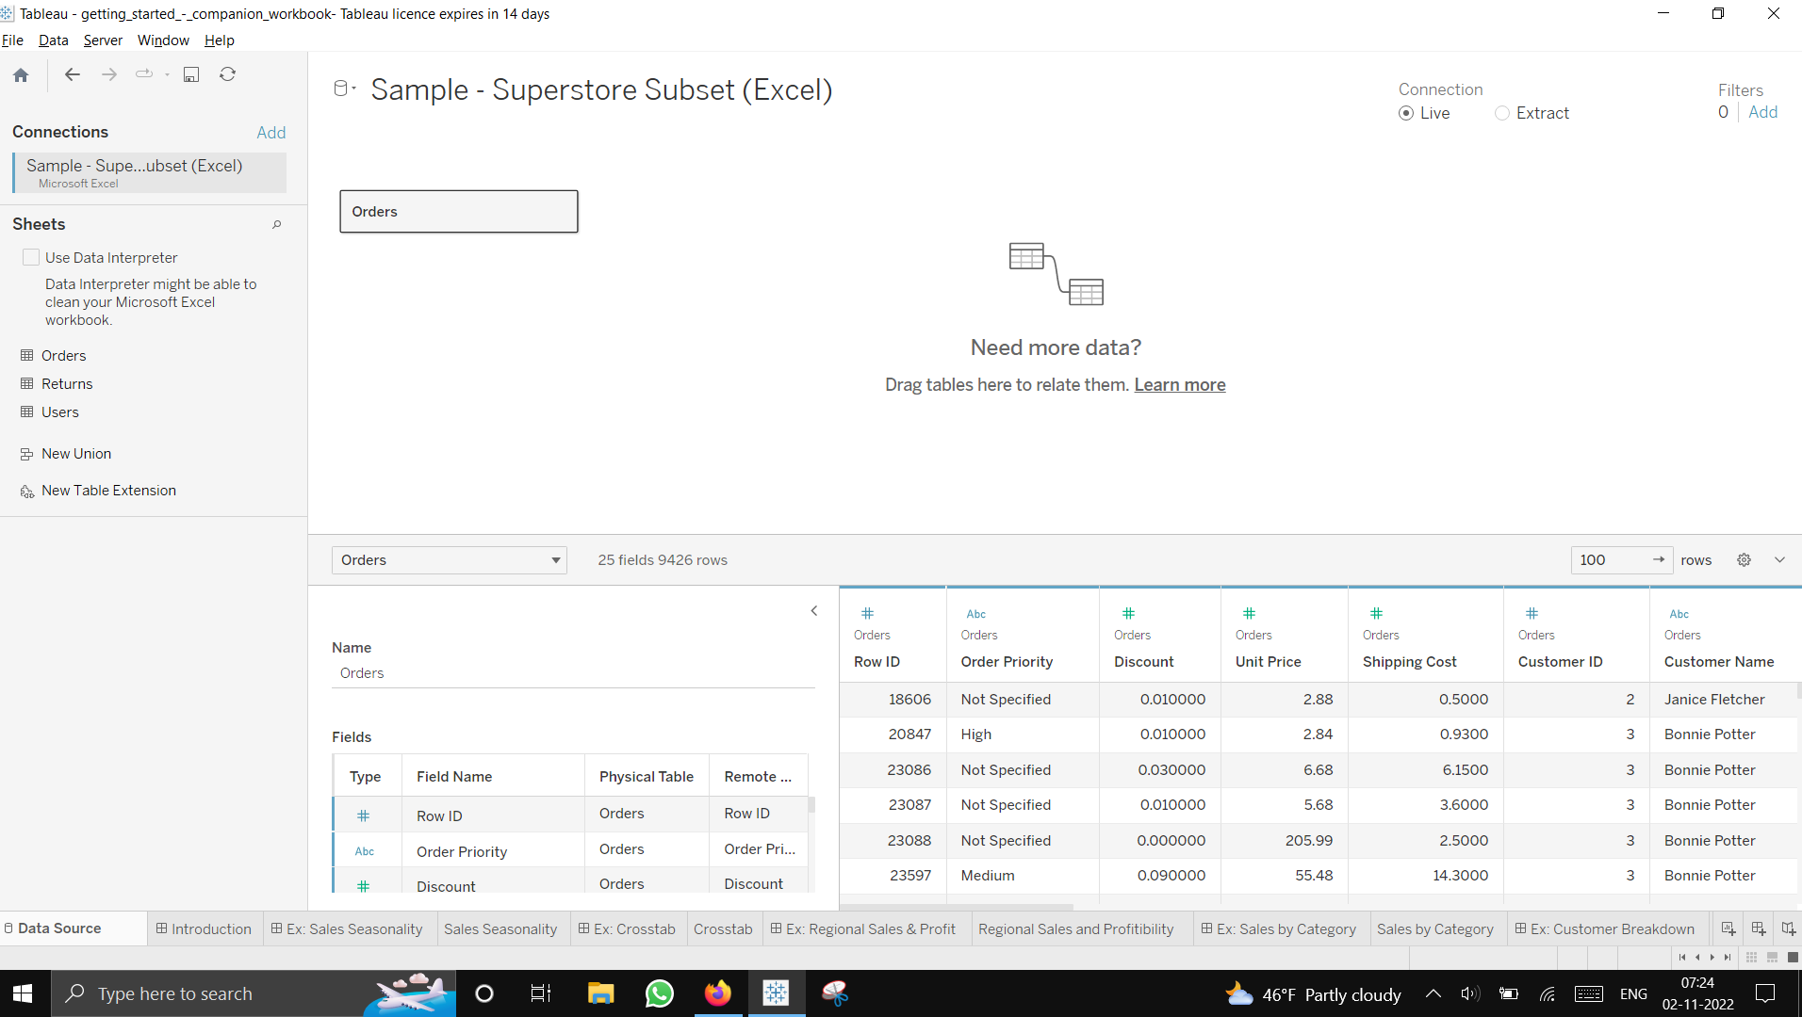

**Sales Seasonality**

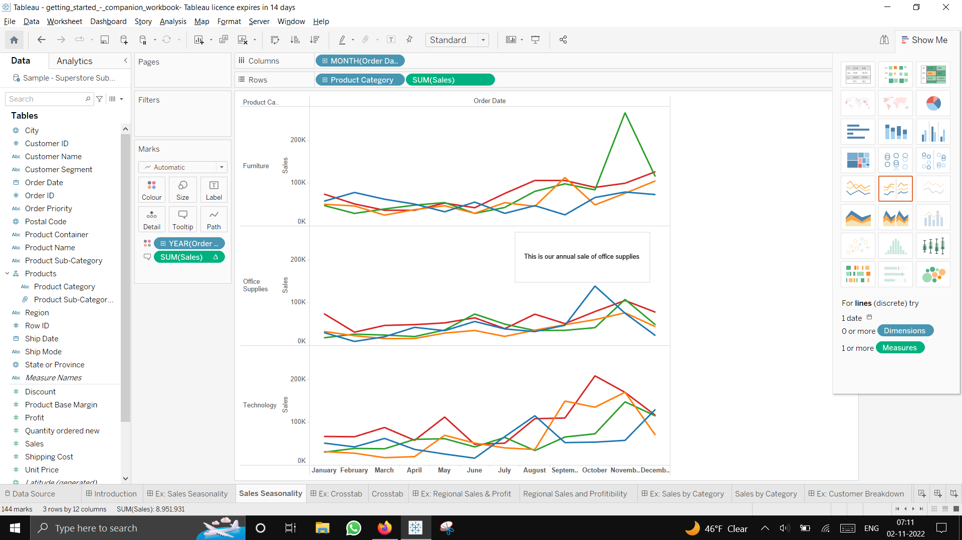

**Crosstab**

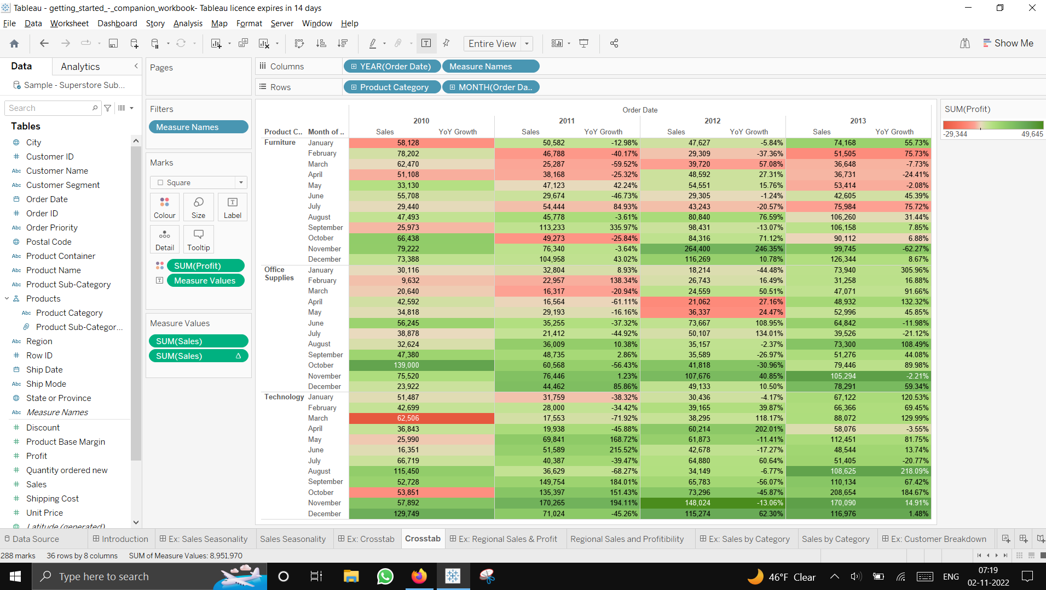

**Regional Sales and Profitability**

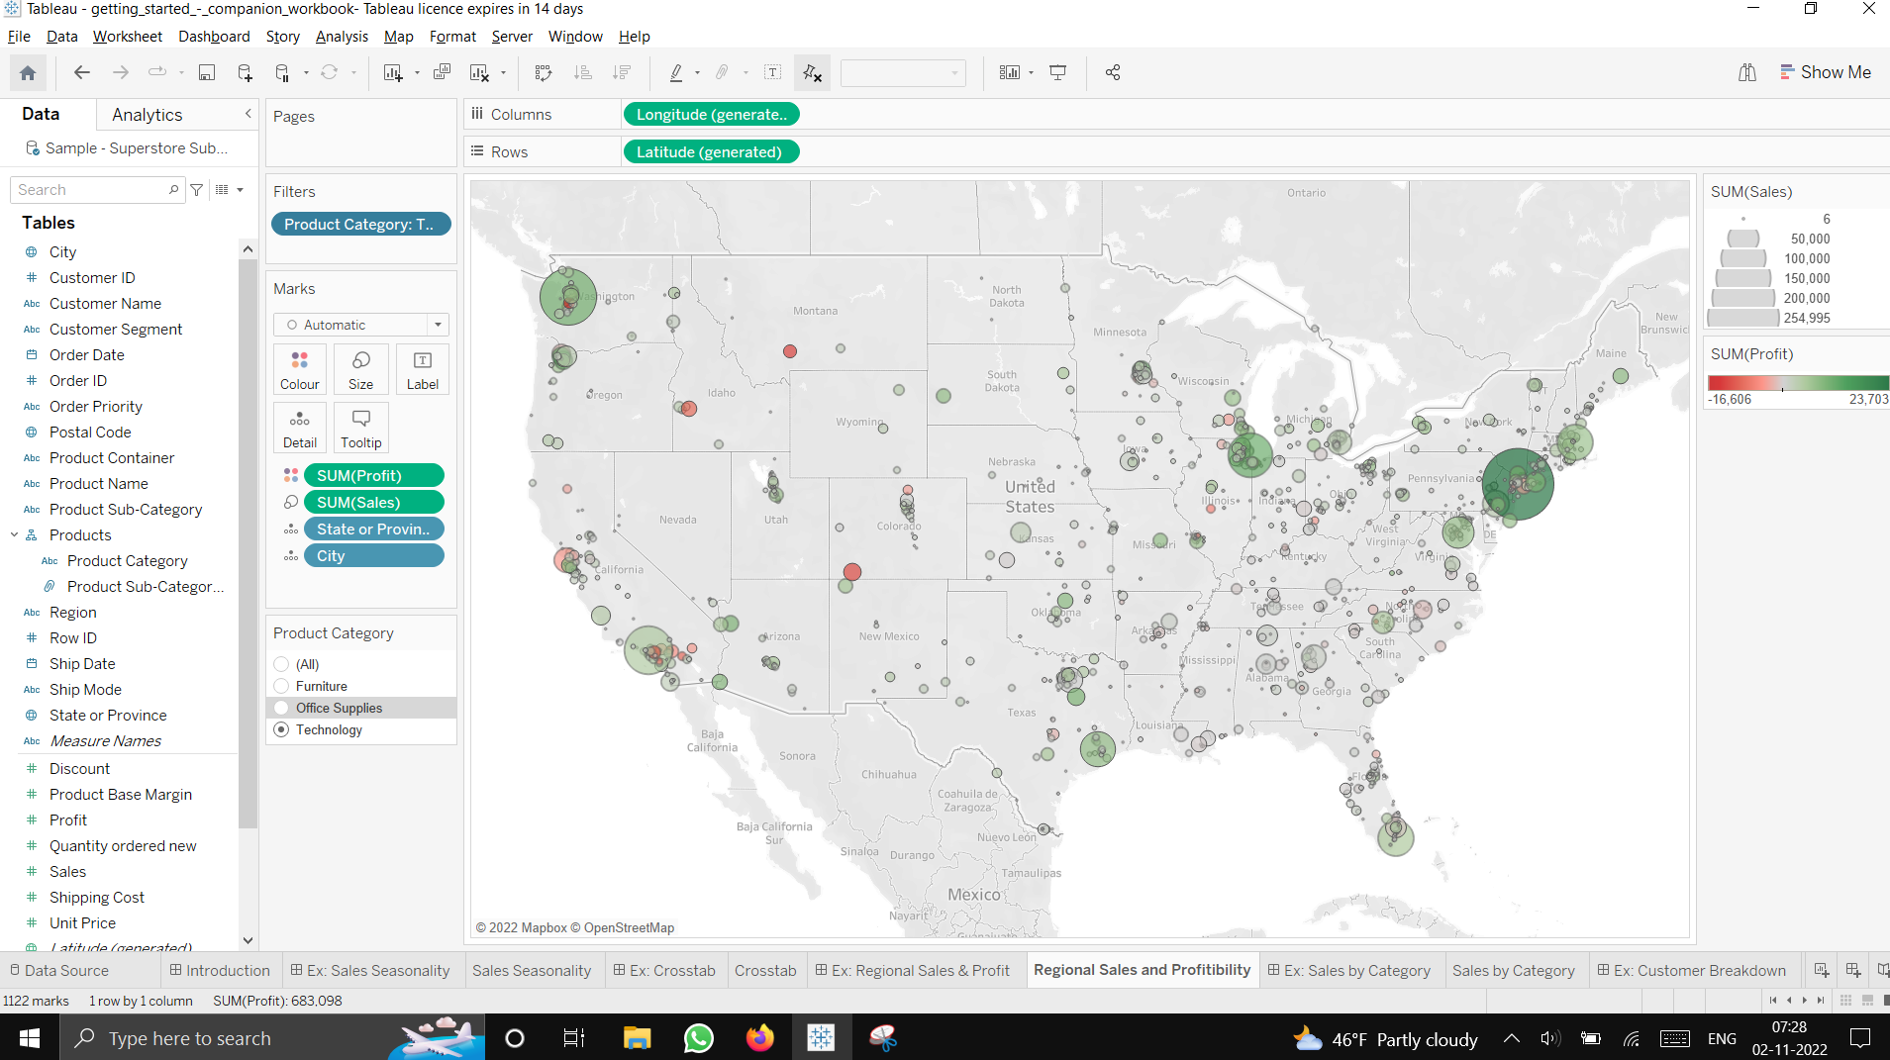

**Sales by Category**

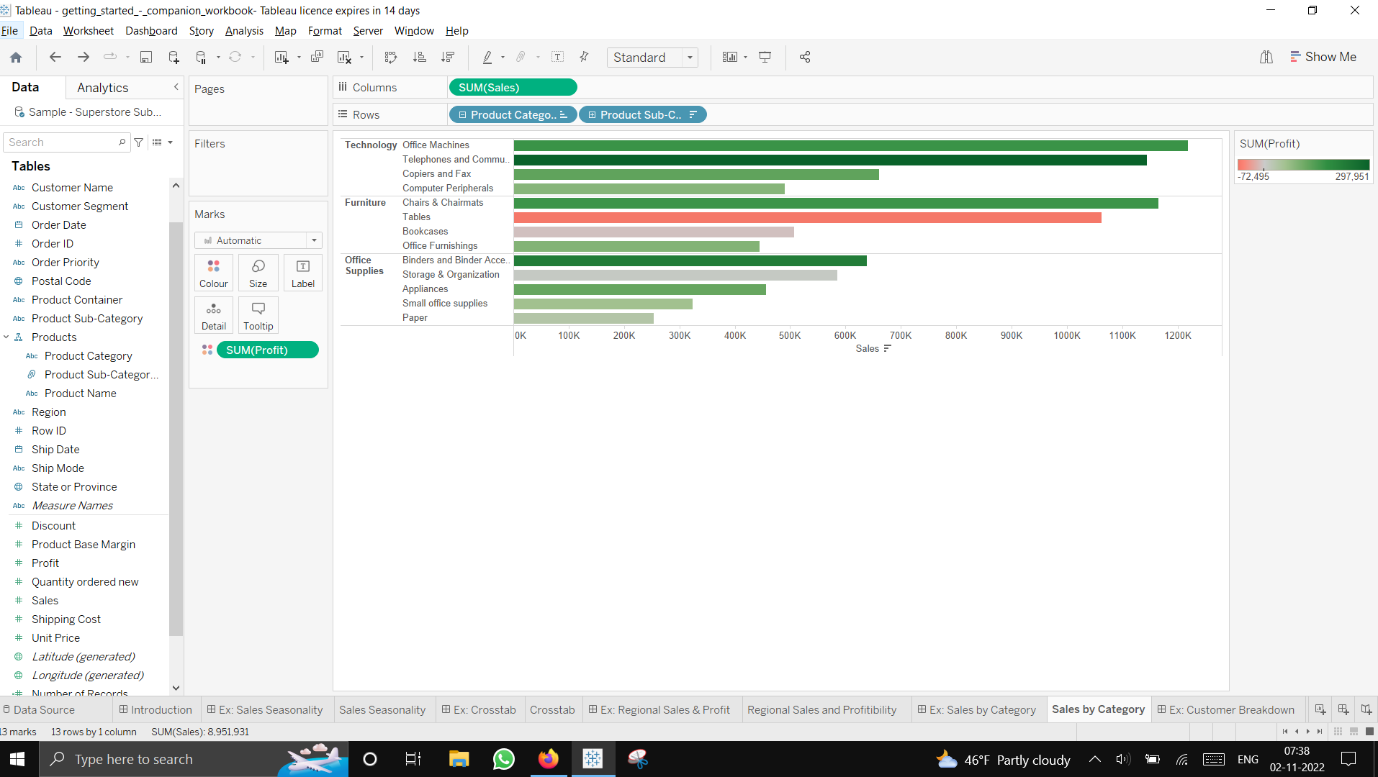

**Customer Breakdown**

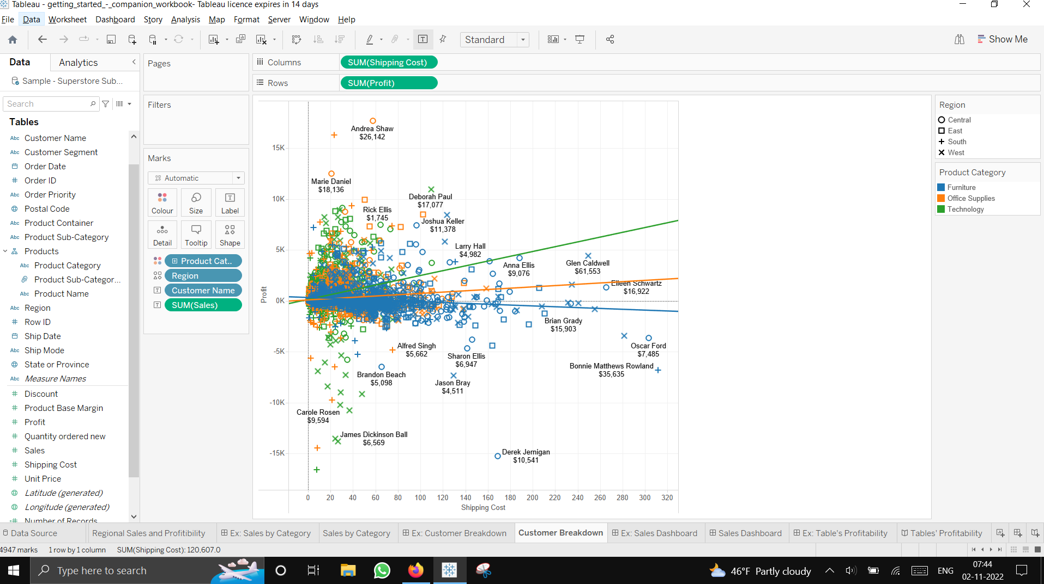

**Looking at underlying customer data that are causing the drop in profits for furniture**

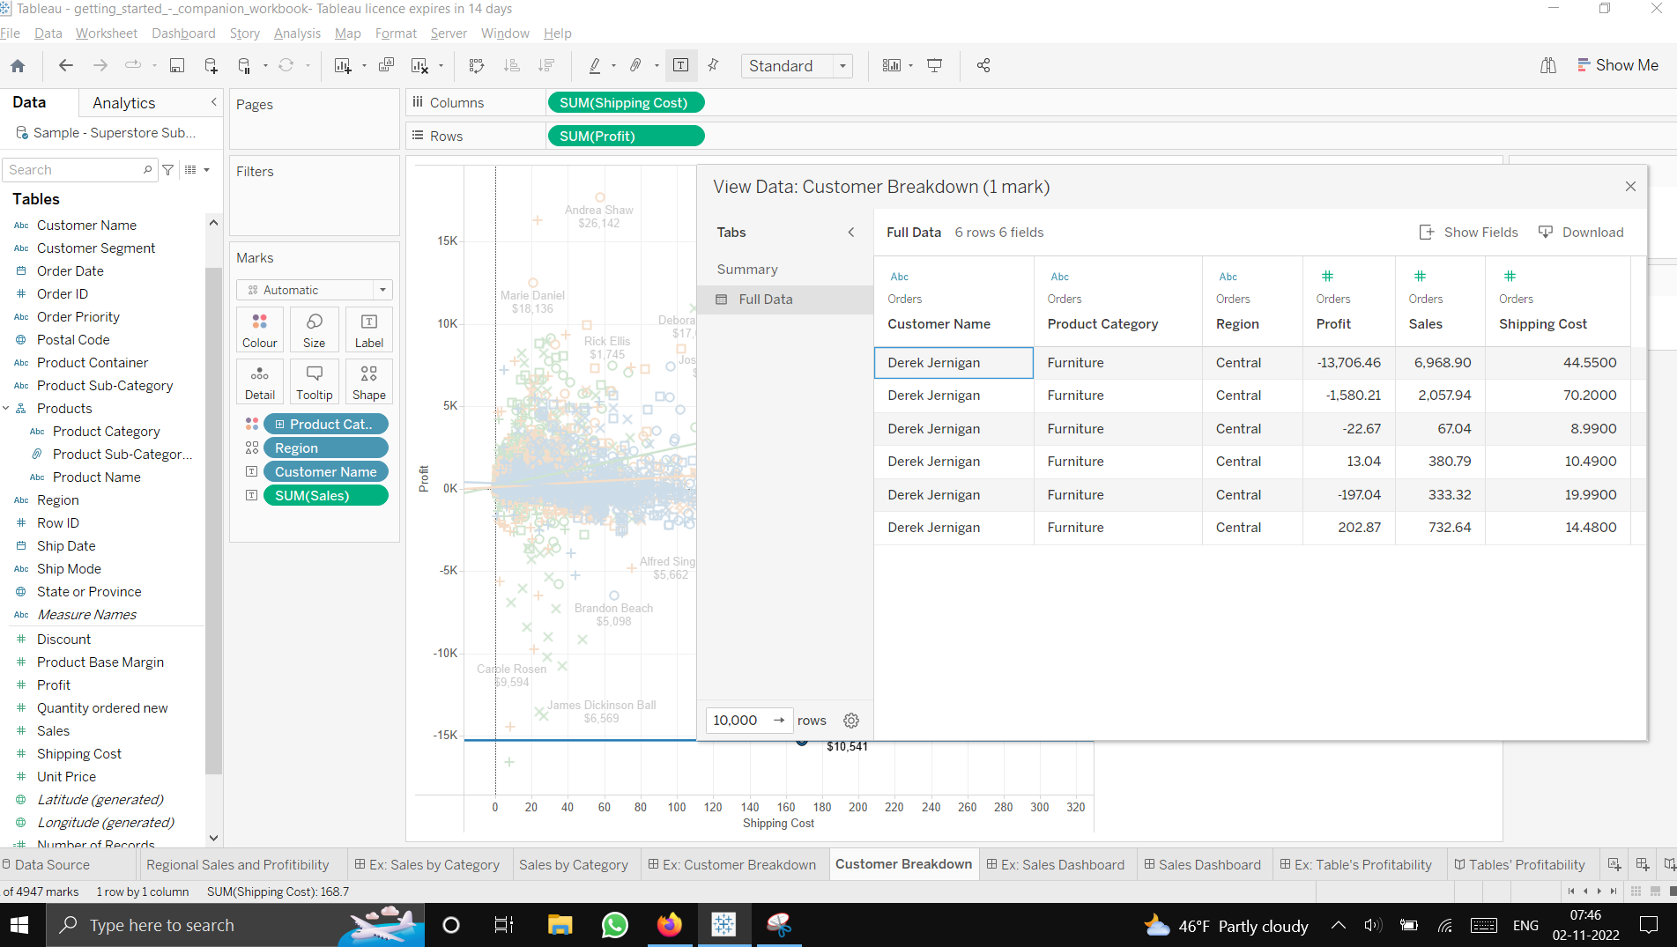

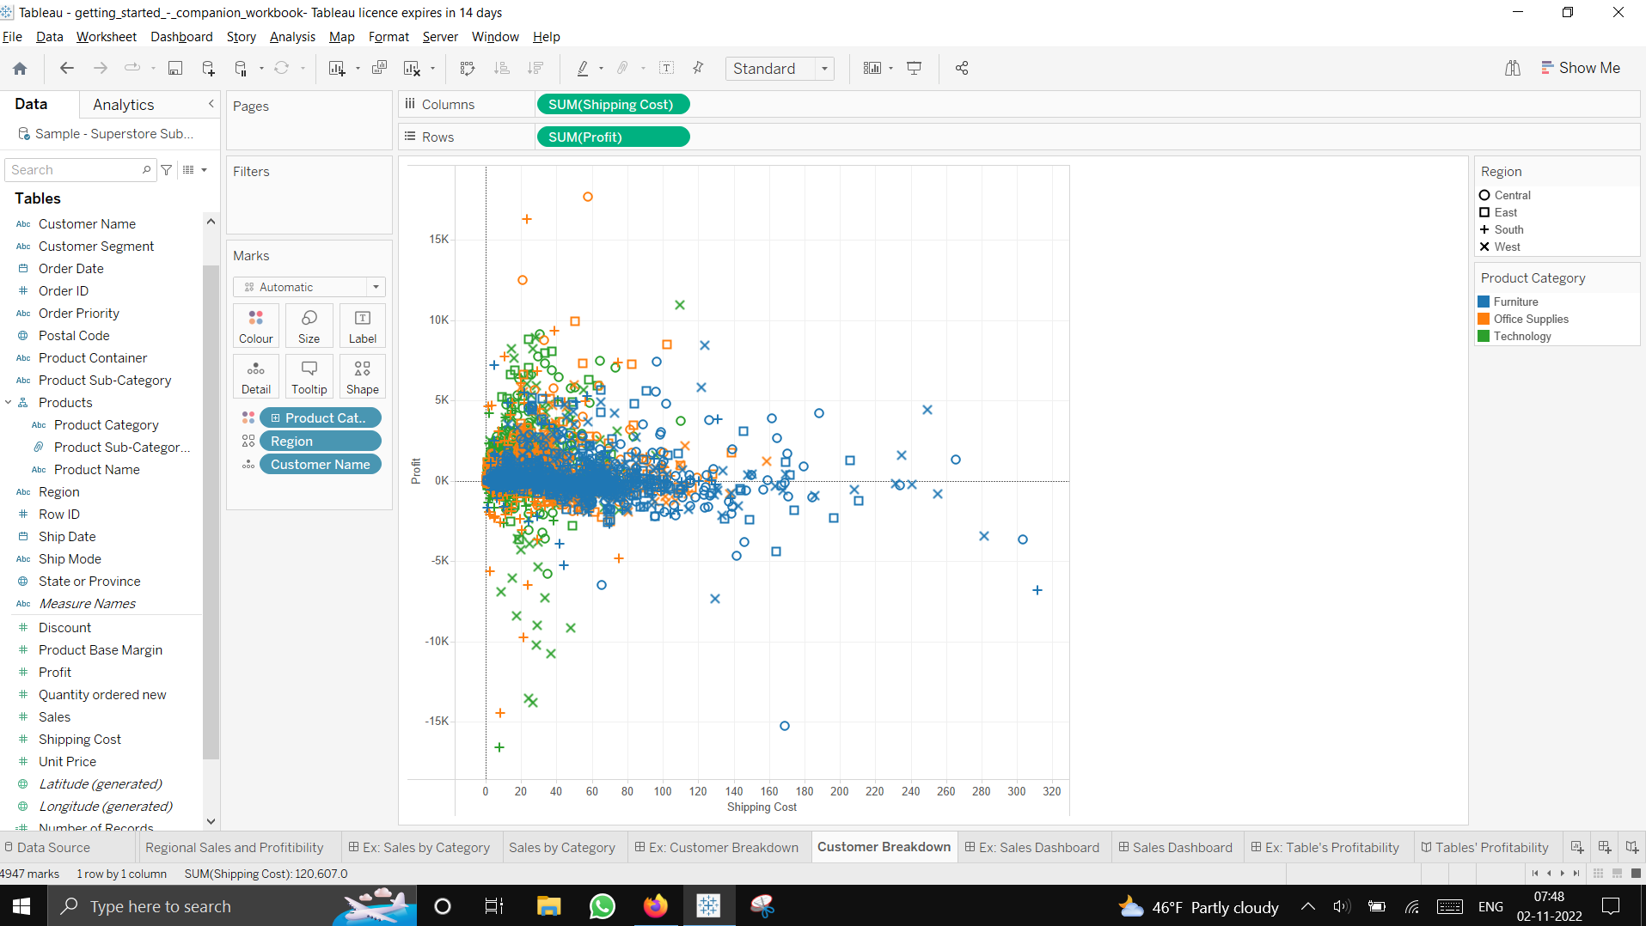

**Sales Dashboard**

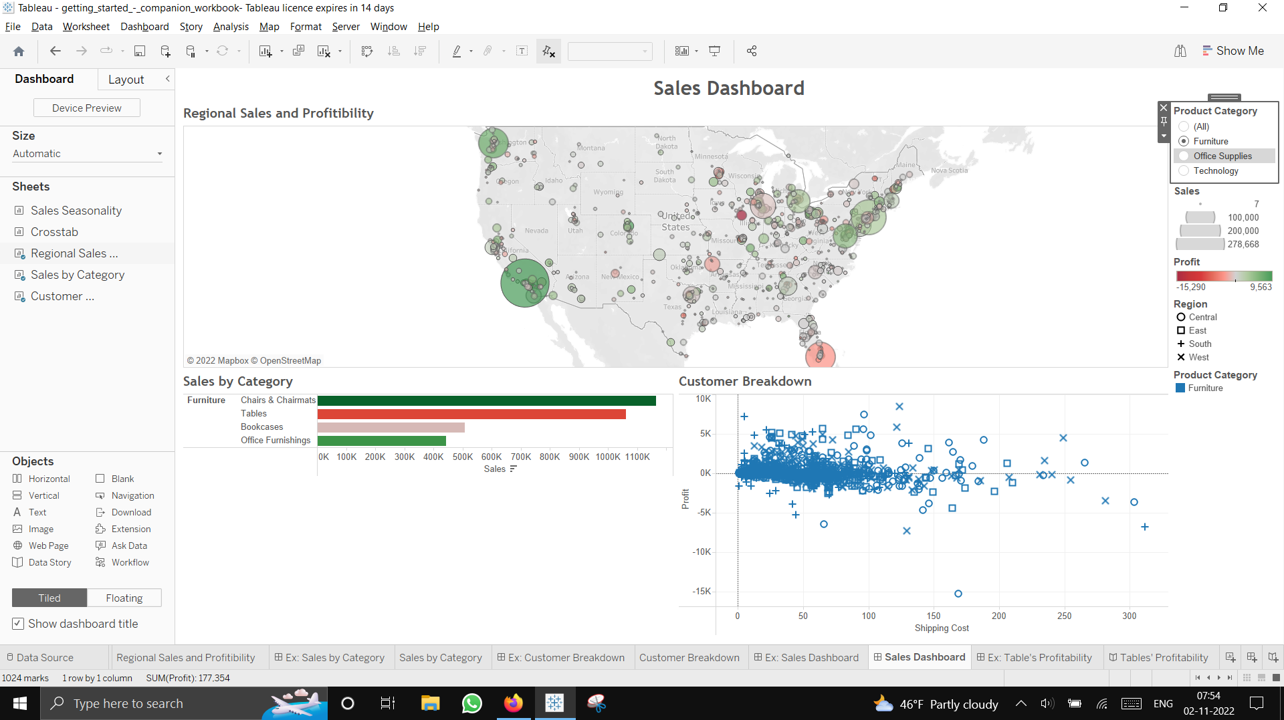

**Filtering dashboard by a point on regional sales**

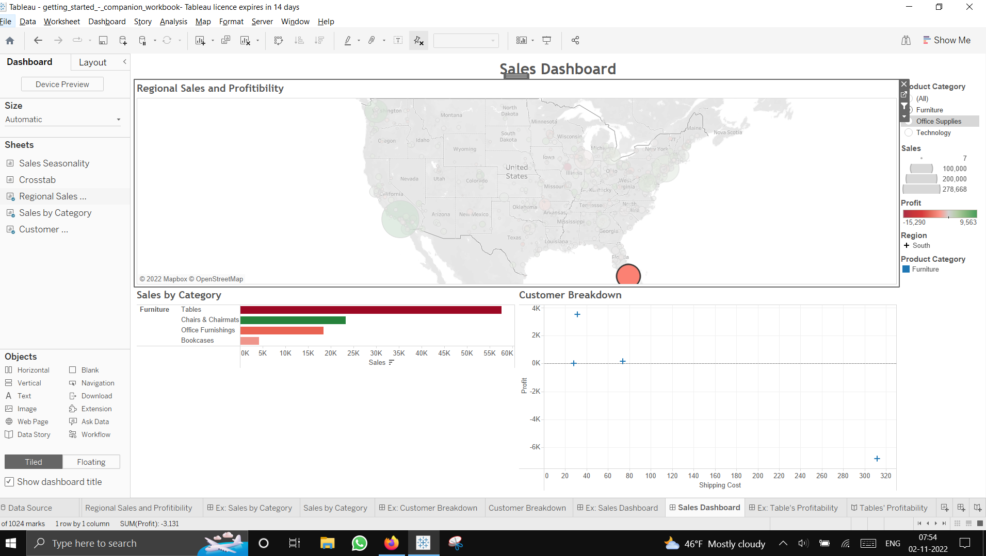

**Story**

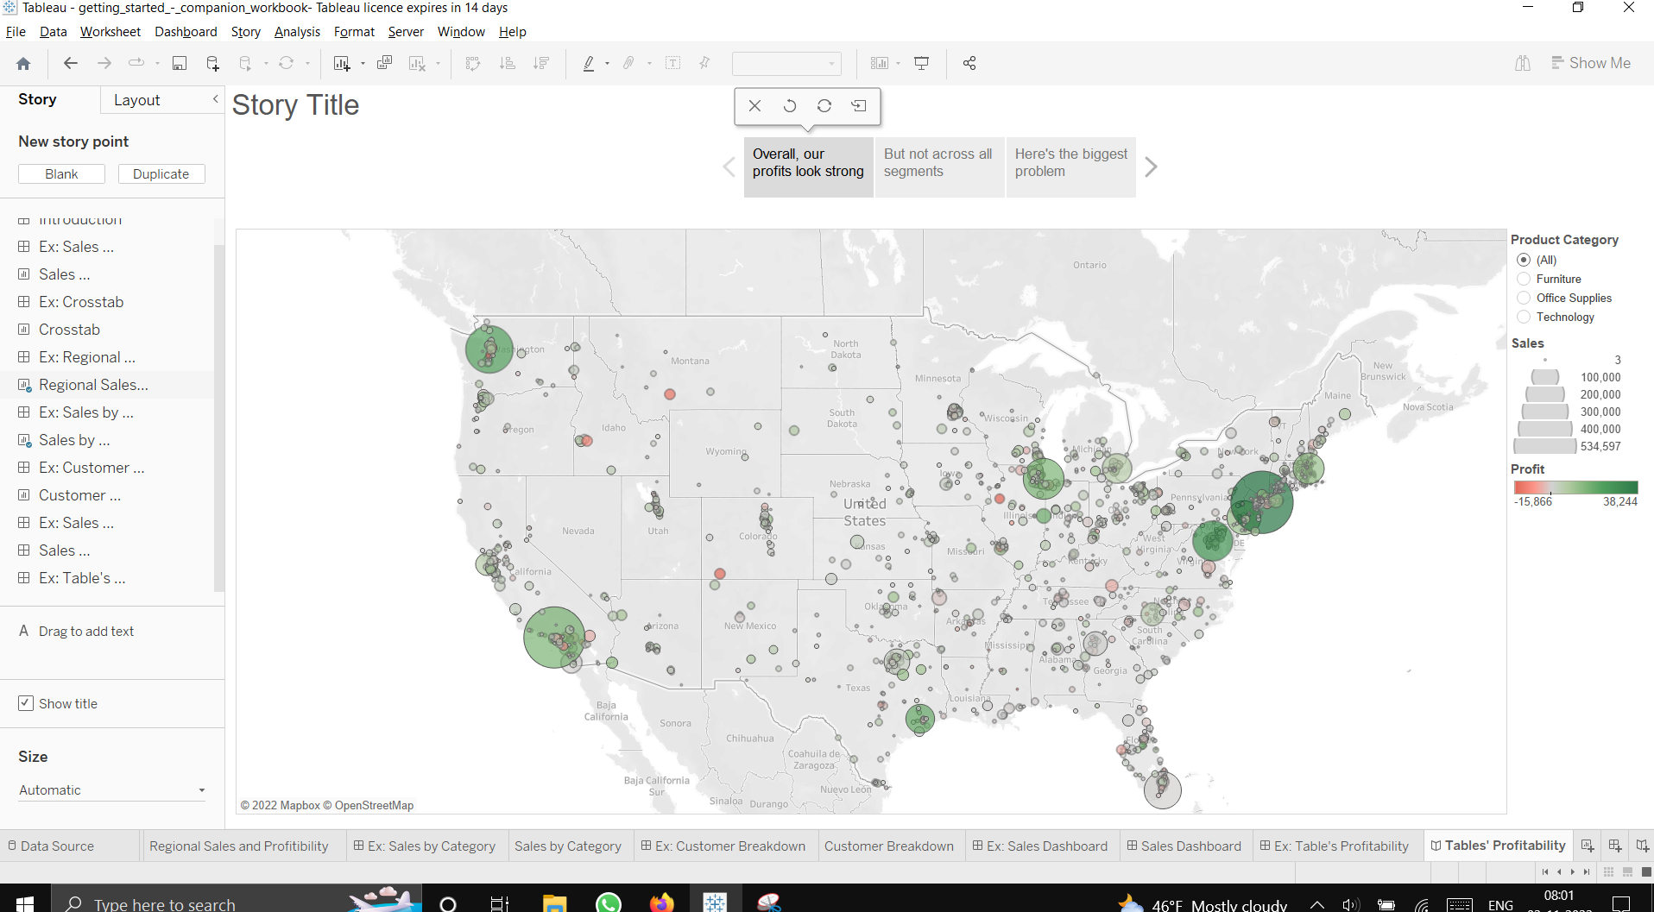

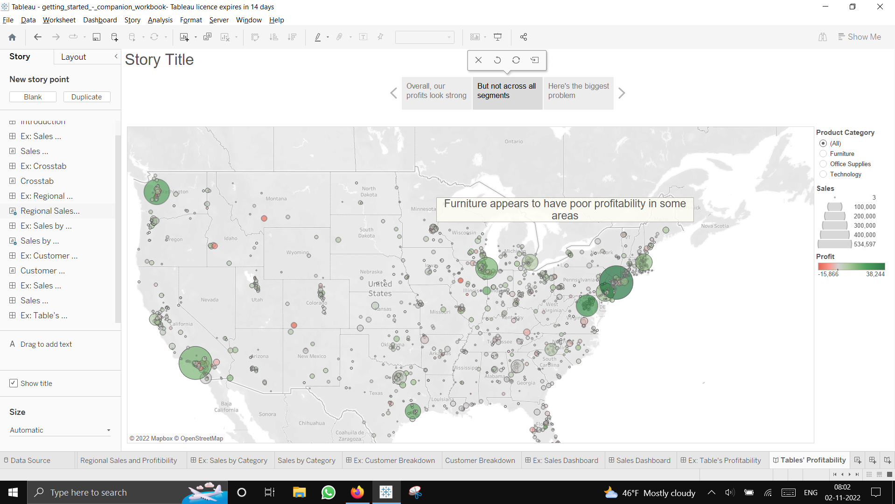

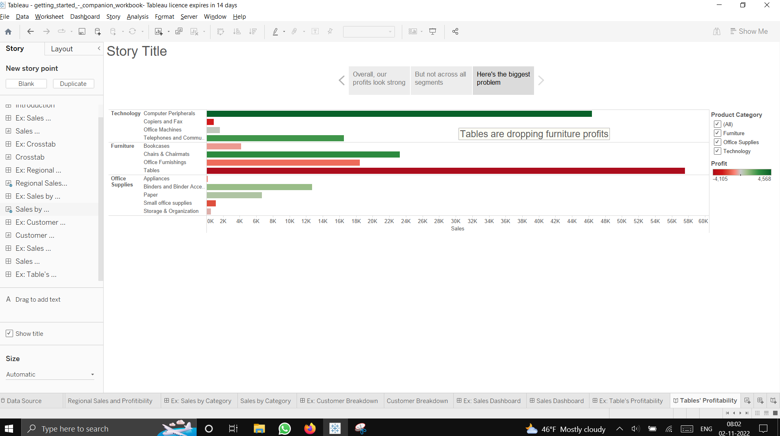

**Dashboard in story**

